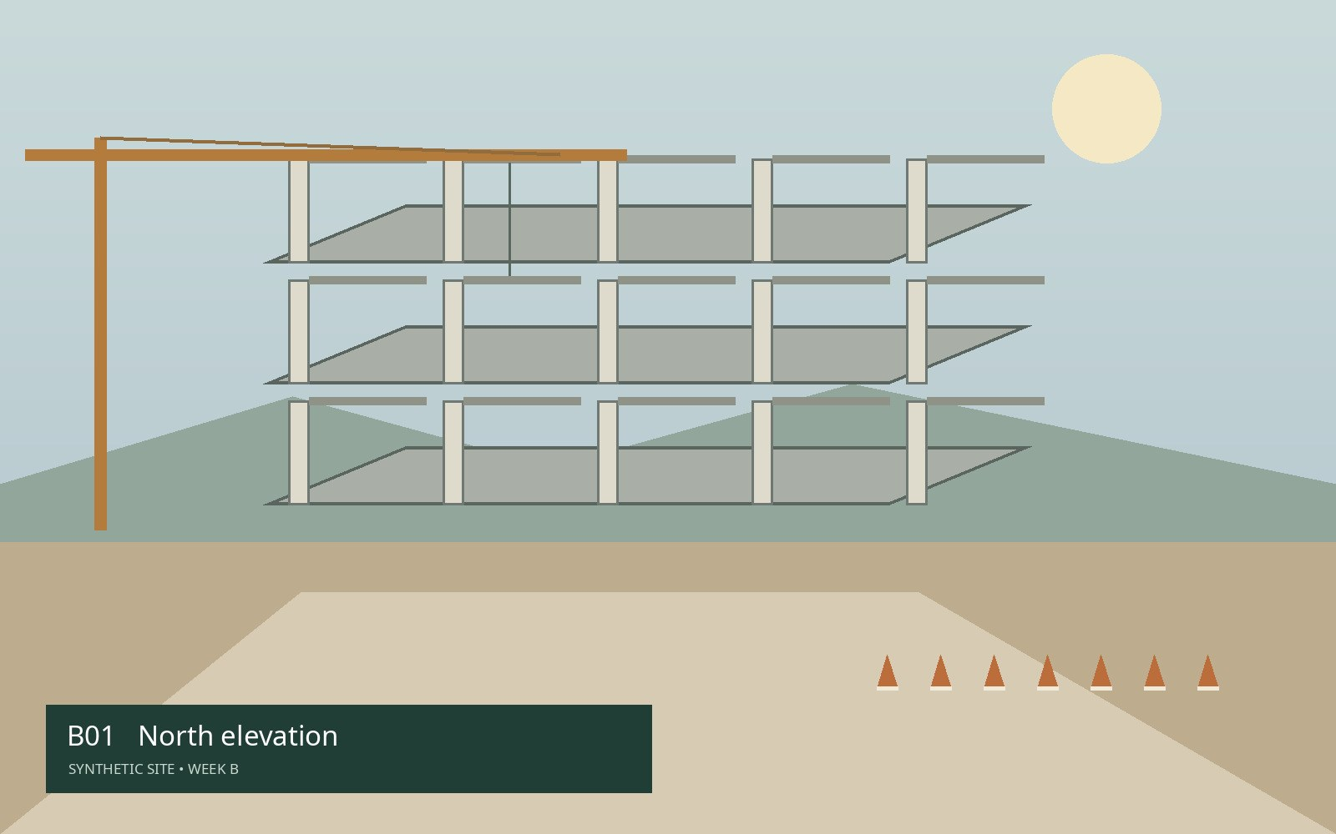 | Photo 01  Asset: 0001  North elevation: concrete columns and level-one formwork in place. Confirm the open bays before next week.
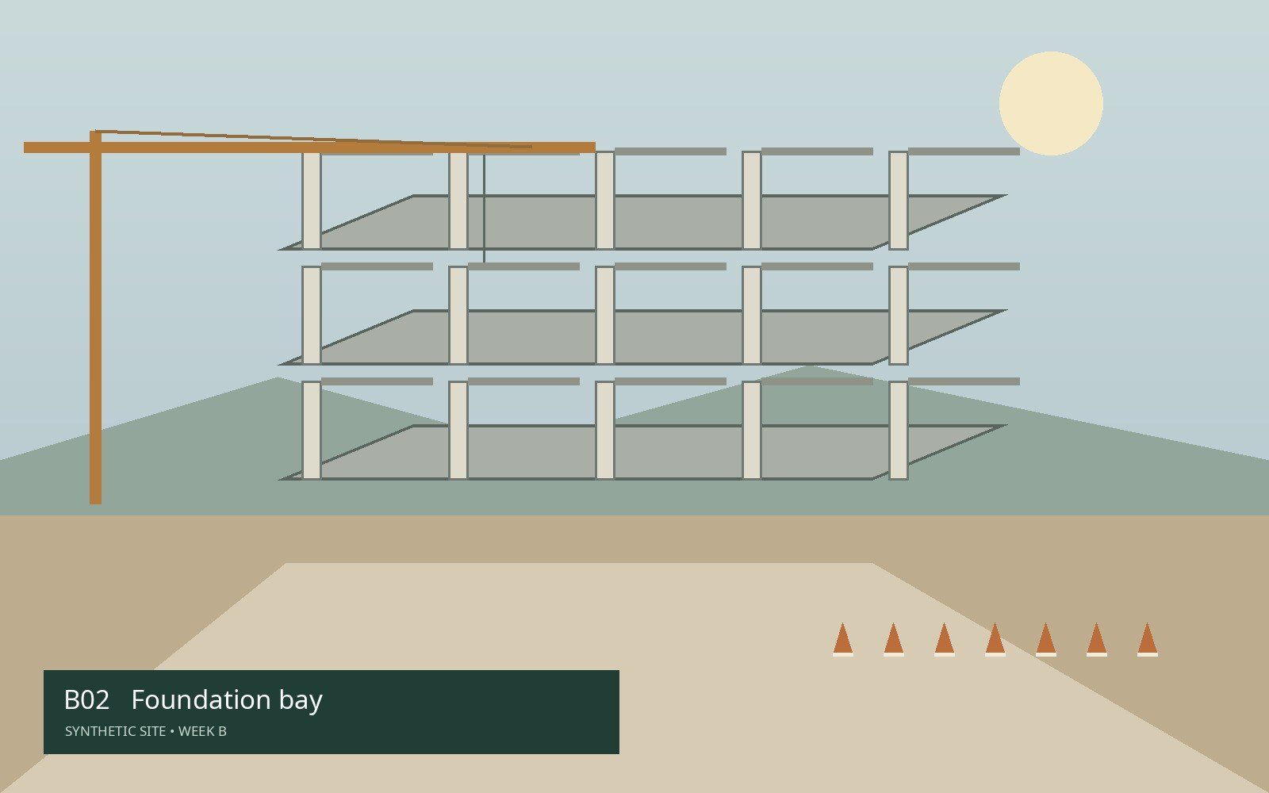 | Photo 02  Asset: 0002  Fundação — seção norte. Reinforcement layout visible; concrete placement to be reviewed.
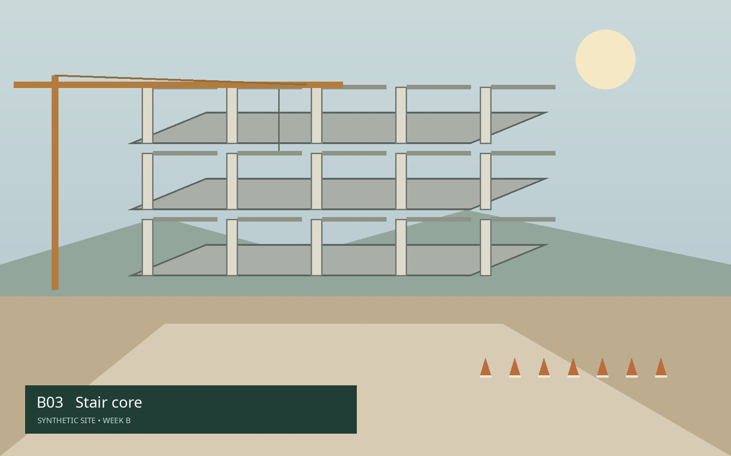 | Photo 03  Asset: 0003  Stair core: lower flight and landing reference. Maintain this view for the weekly comparison.
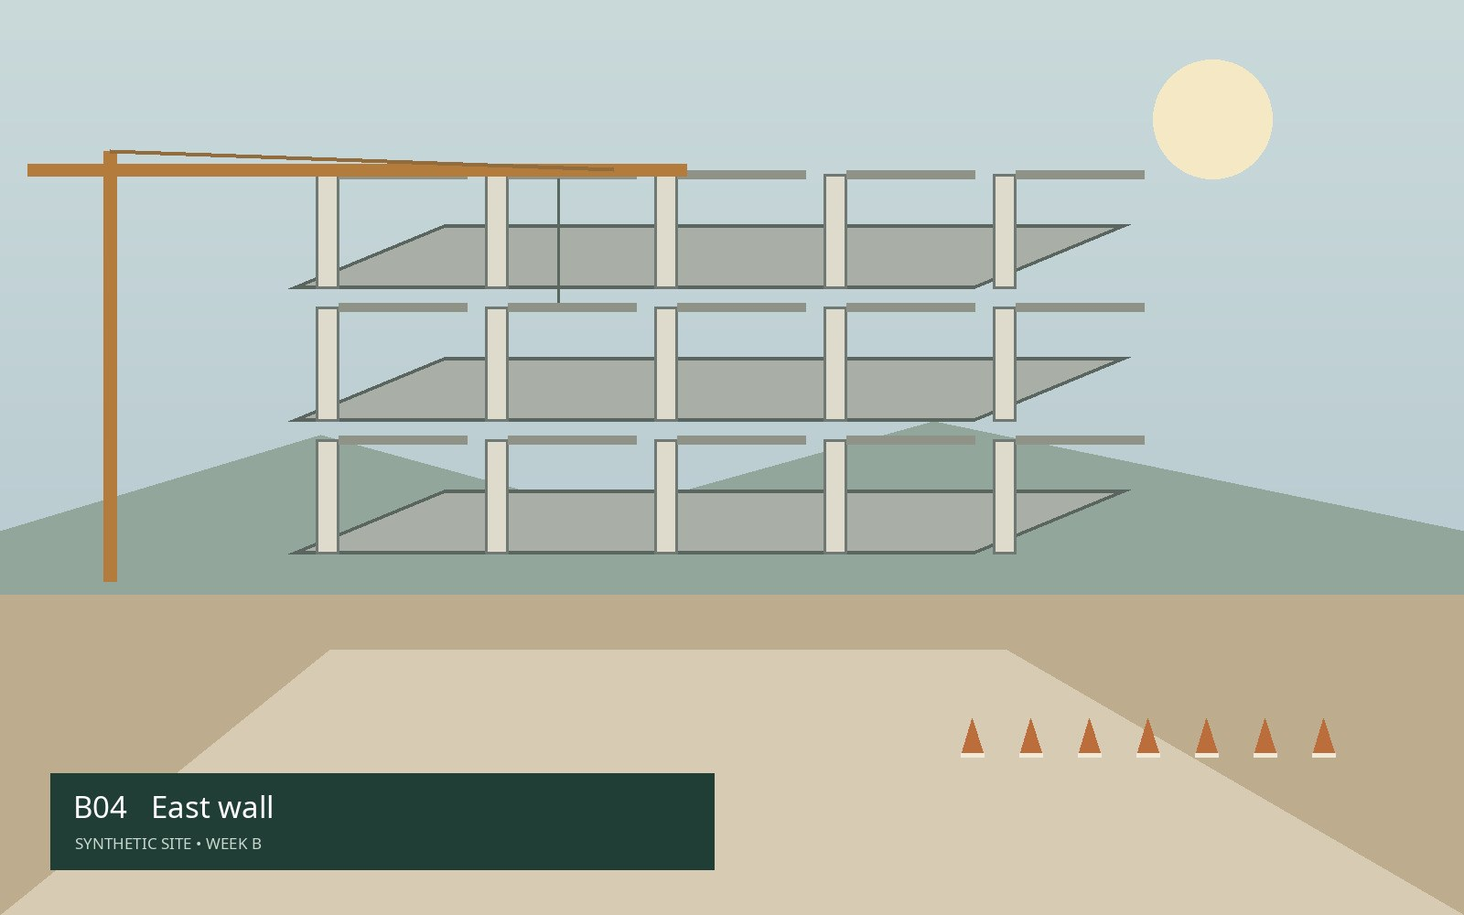 | Photo 04  Asset: 0004  East wall: masonry sample panel and perimeter access.
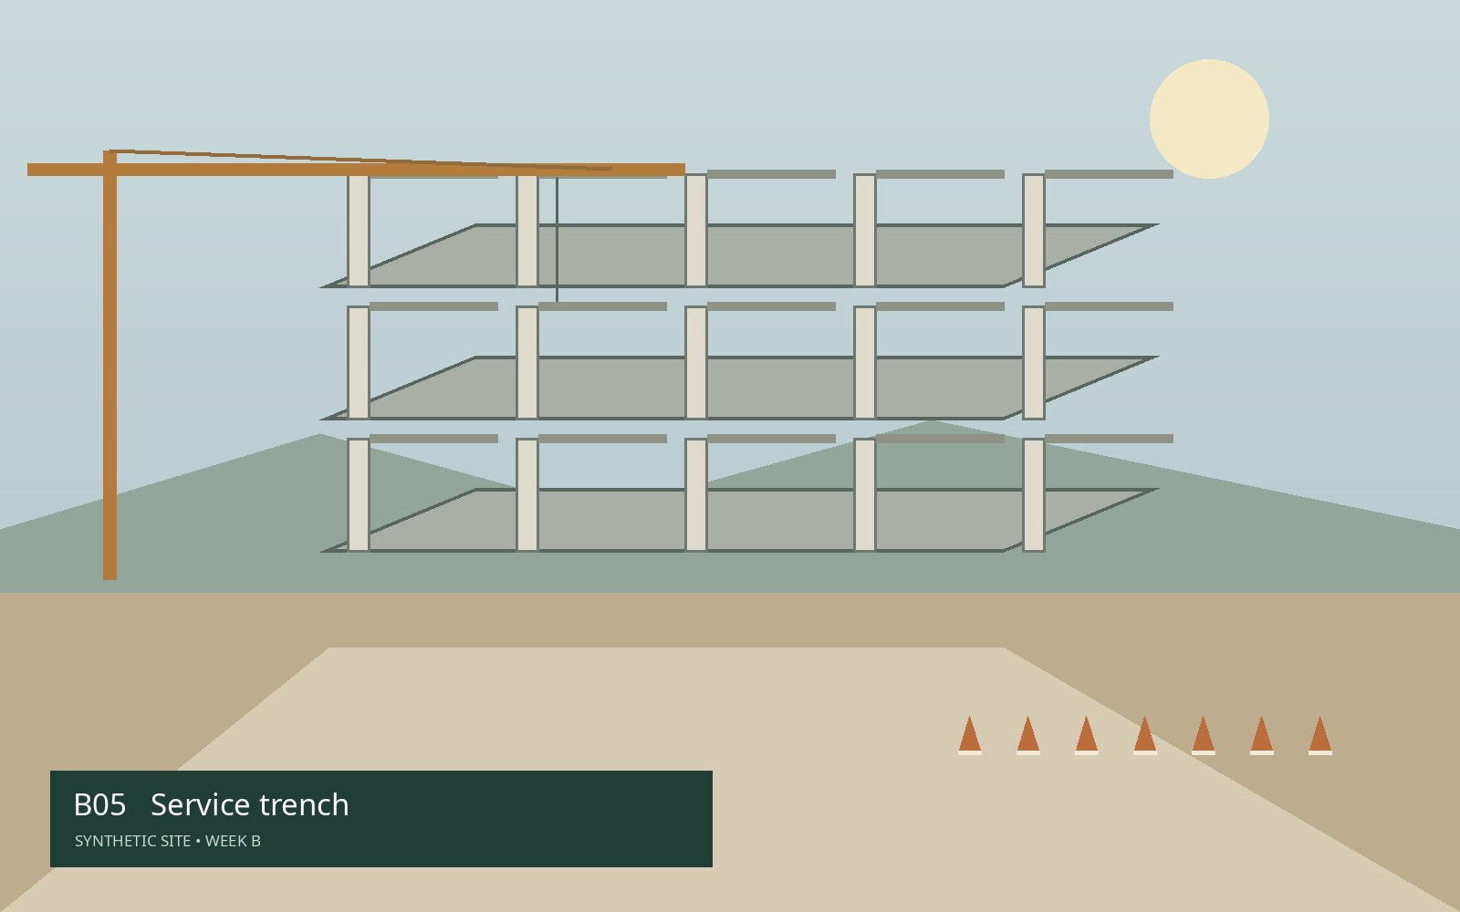 | Photo 05  Asset: 0005  Service trench: alignment reference along the east boundary.
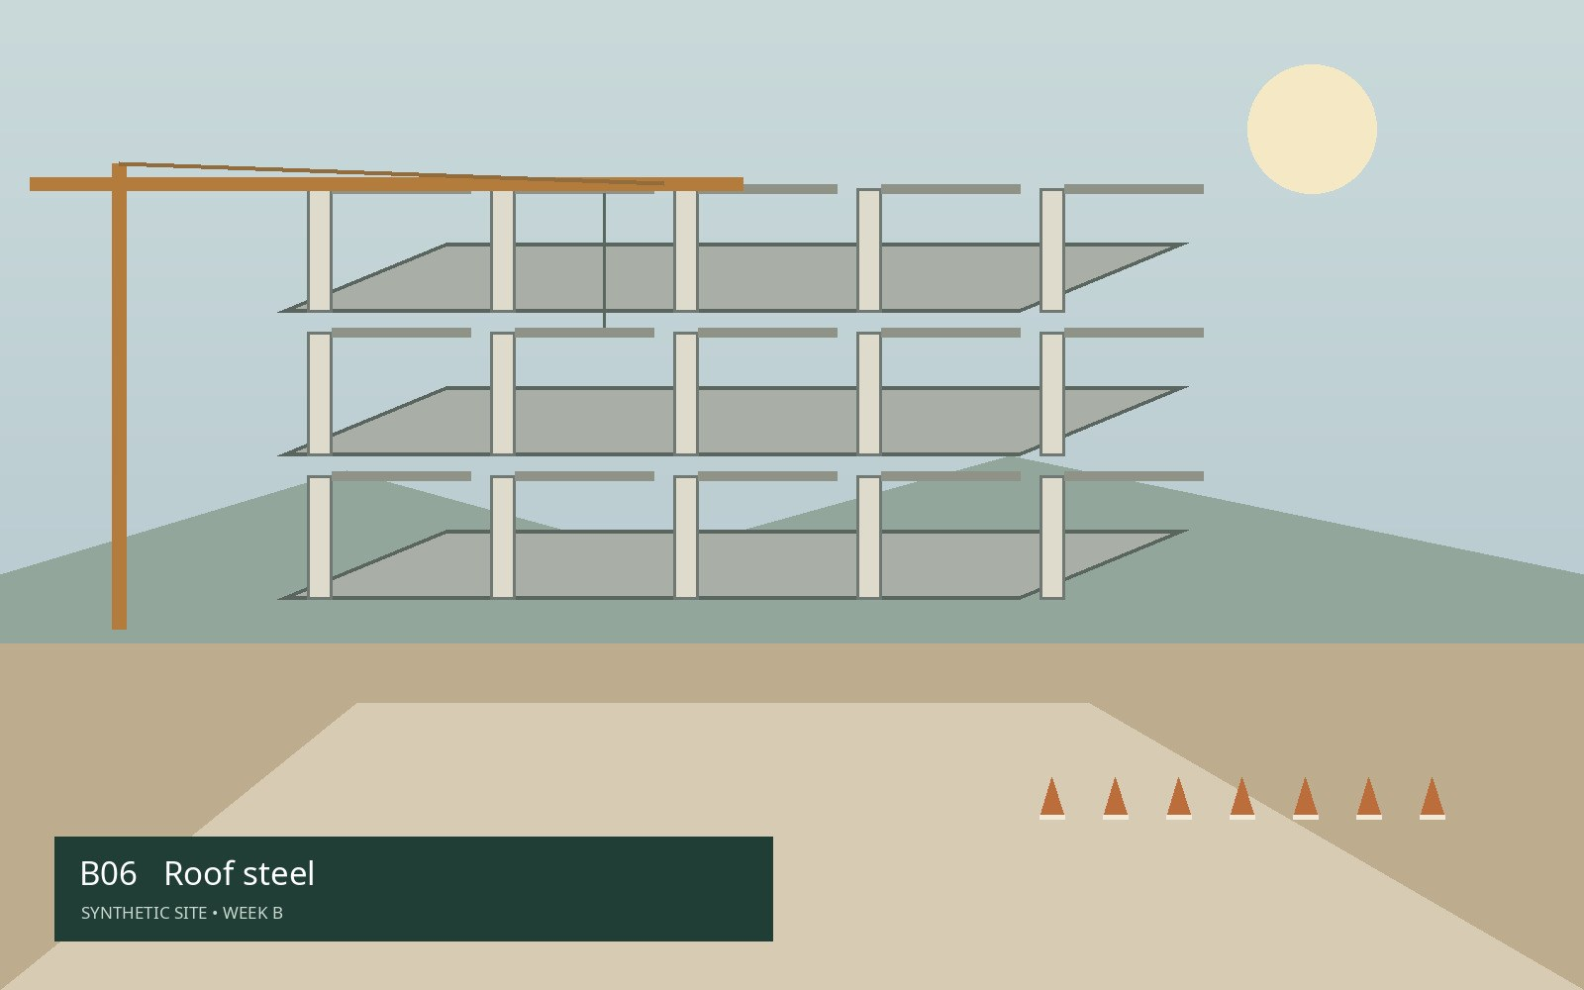 | Photo 06  Asset: 0006  Roof steel: primary beam connections viewed from ground level.
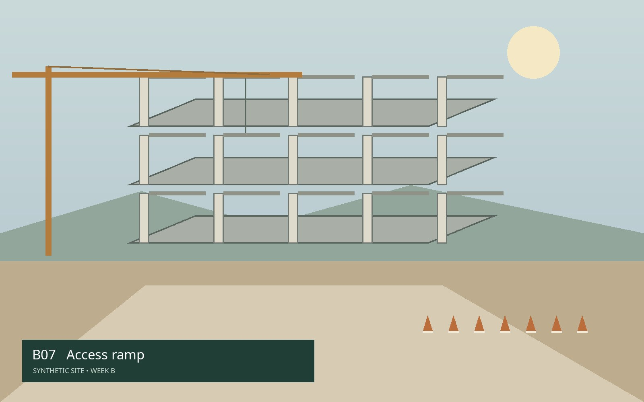 | Photo 07  Asset: 0007  Access ramp: temporary edge protection and approach.
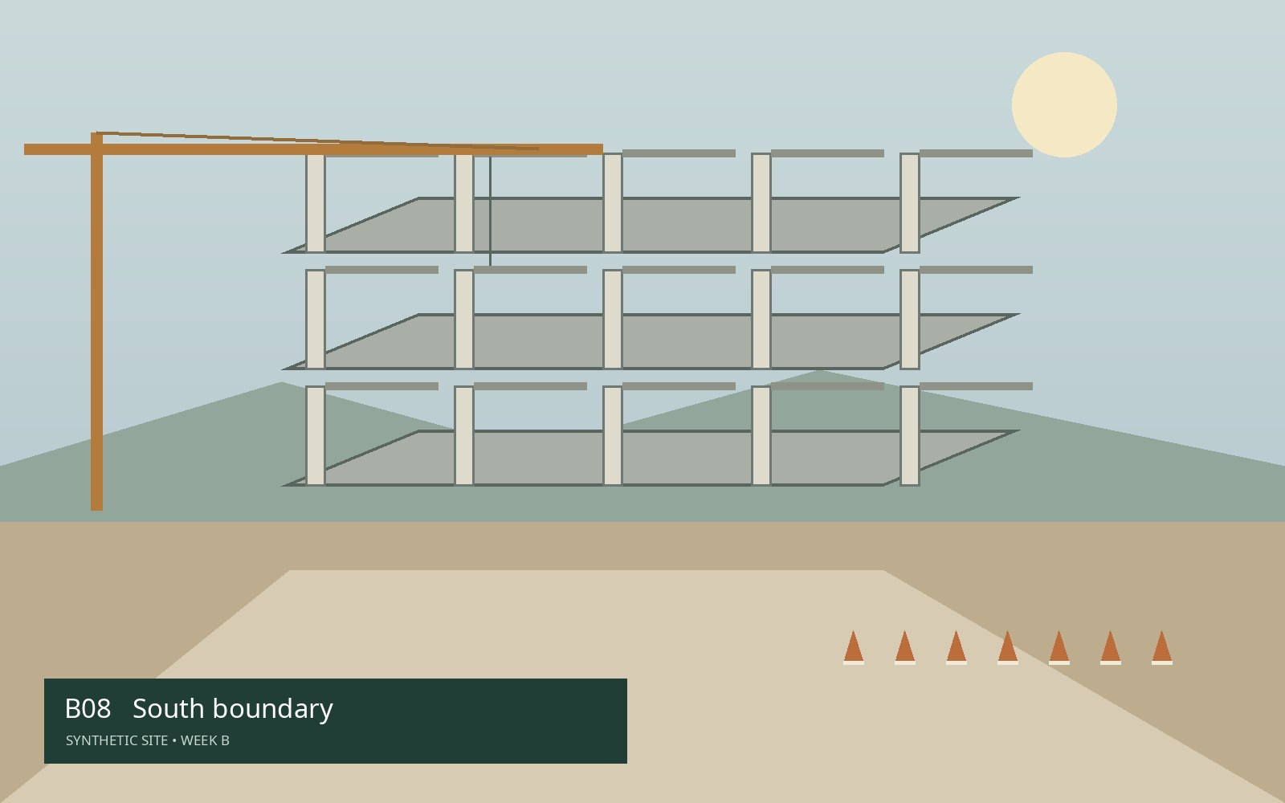 | Photo 08  Asset: 0008  South boundary: site access and perimeter reference.

